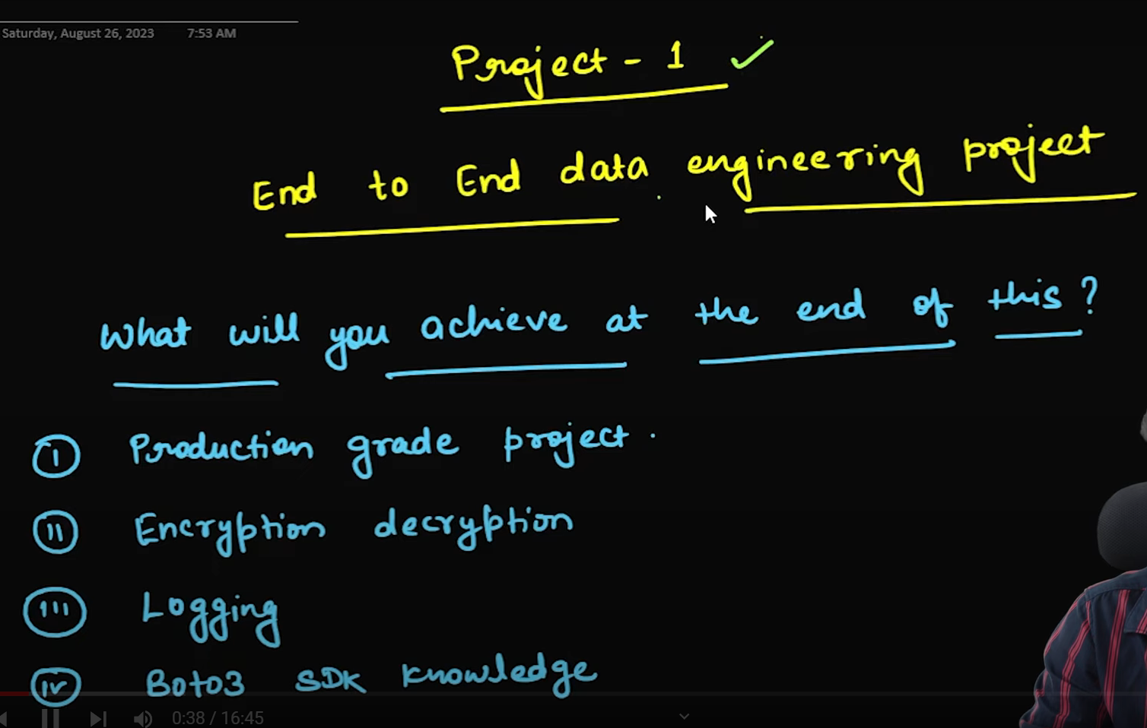

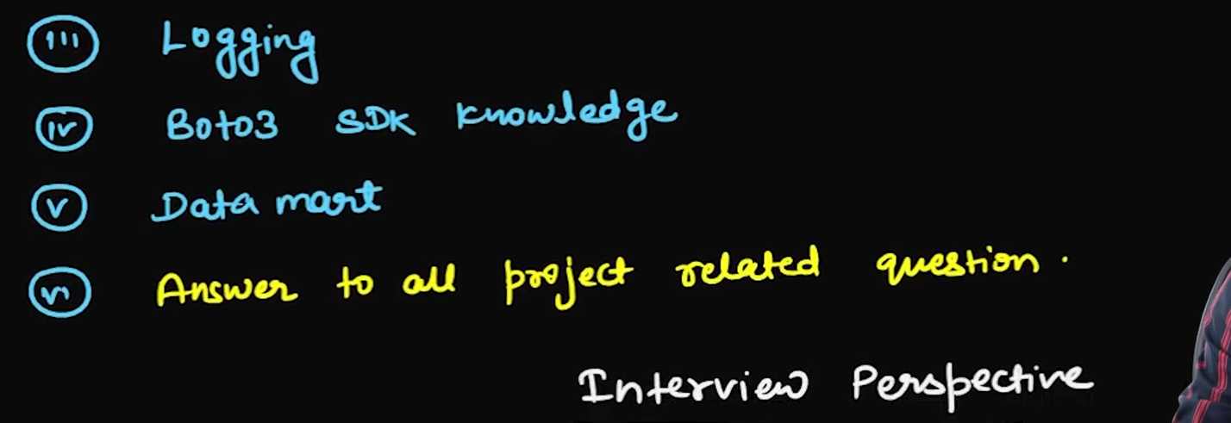

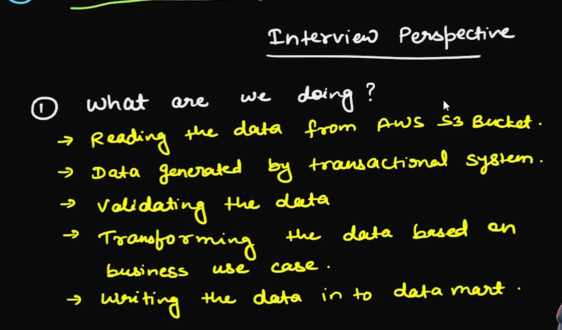

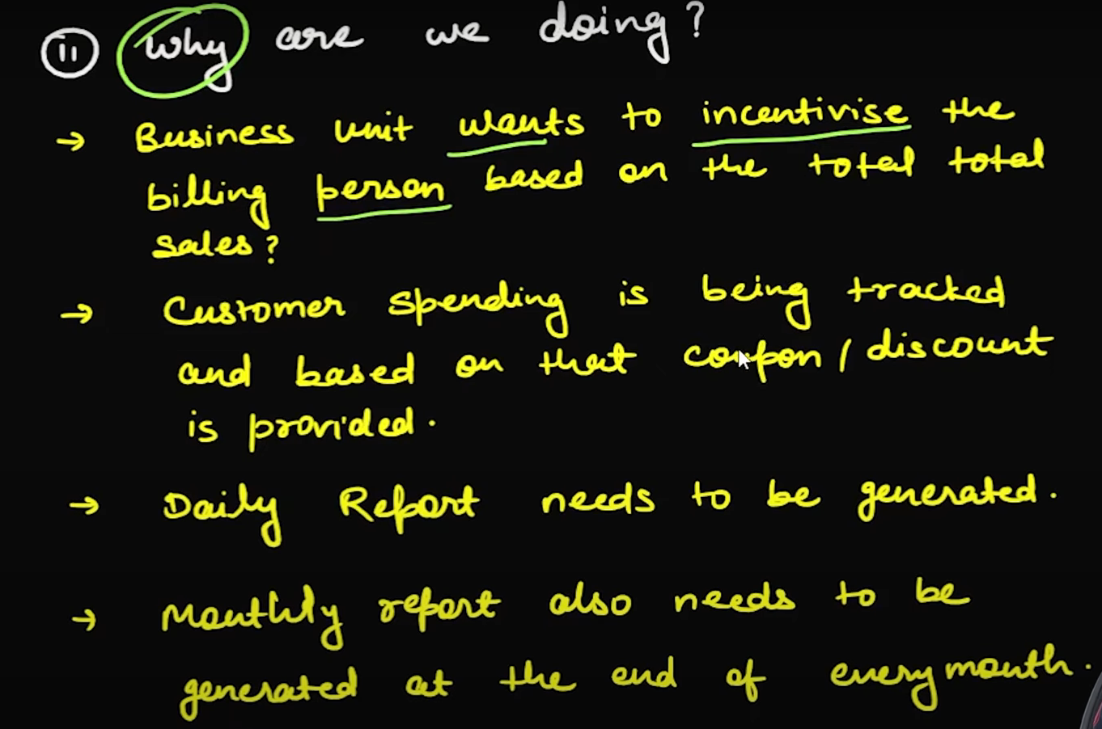

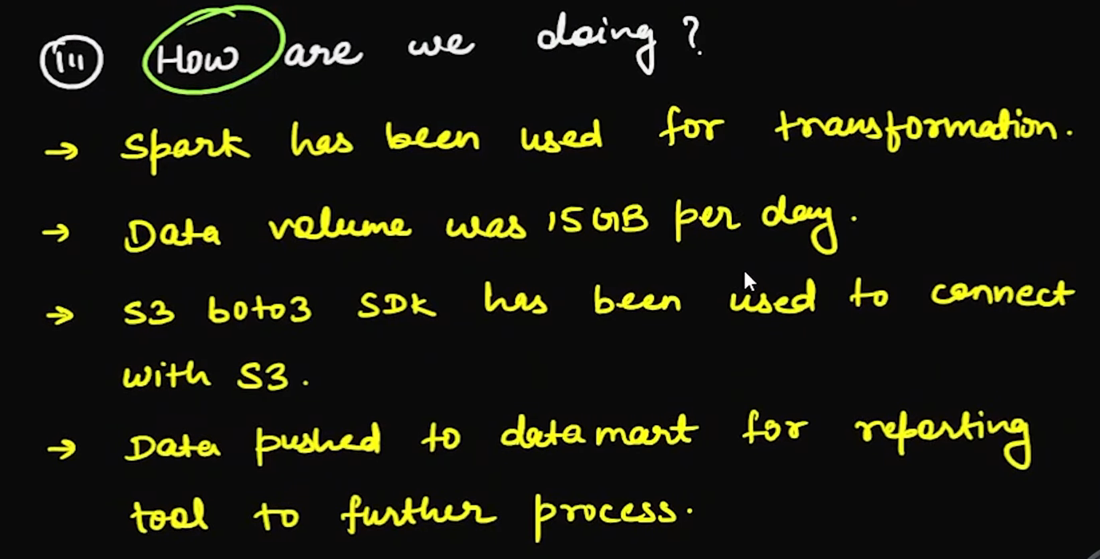

Below is the table like the bill we get in the reliance fresh

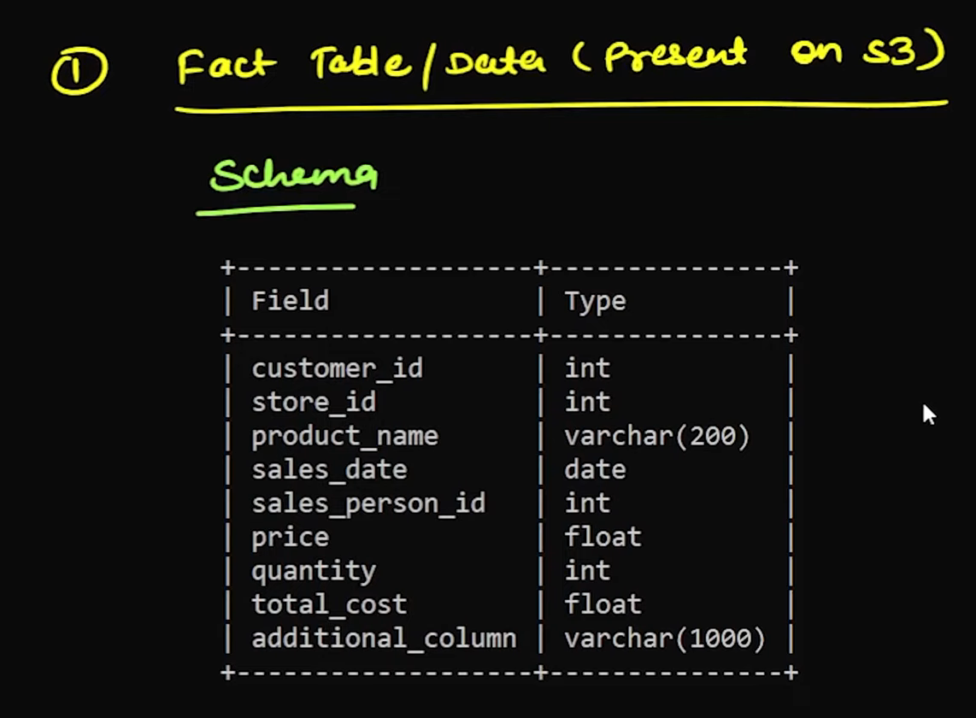

**Fact Table / Data**

| **Field** | **Type** |
| --- | --- |
| customer_id | int |
| store_id | int |
| product_name | varchar(200) |
| sales_date | date |
| sales_person_id | int |
| price | float |
| quantity | int |
| total_cost | float |
| additional_column | varchar(1000) |

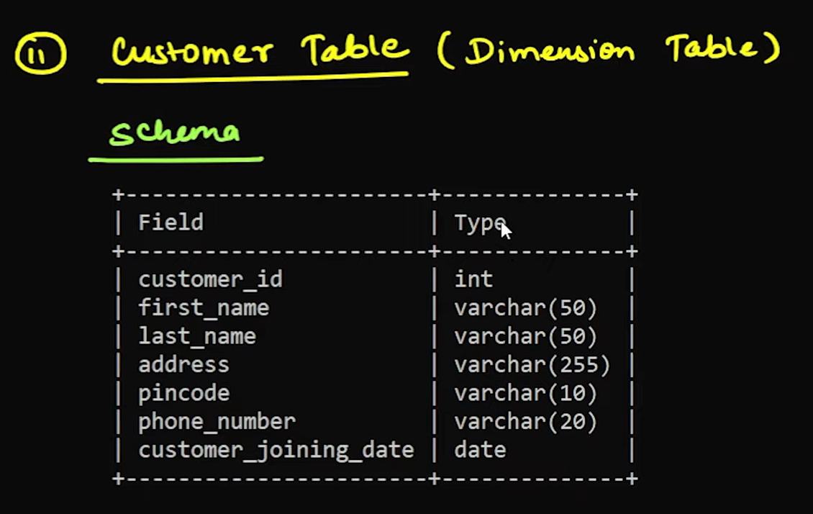

**Customer Table (Dimension Table)**

| **Field** | **Type** |
| --- | --- |
| customer_id | int |
| first_name | varchar(50) |
| last_name | varchar(50) |
| address | varchar(255) |
| pincode | varchar(10) |
| phone_number | varchar(20) |
| customer_joining_date | date |

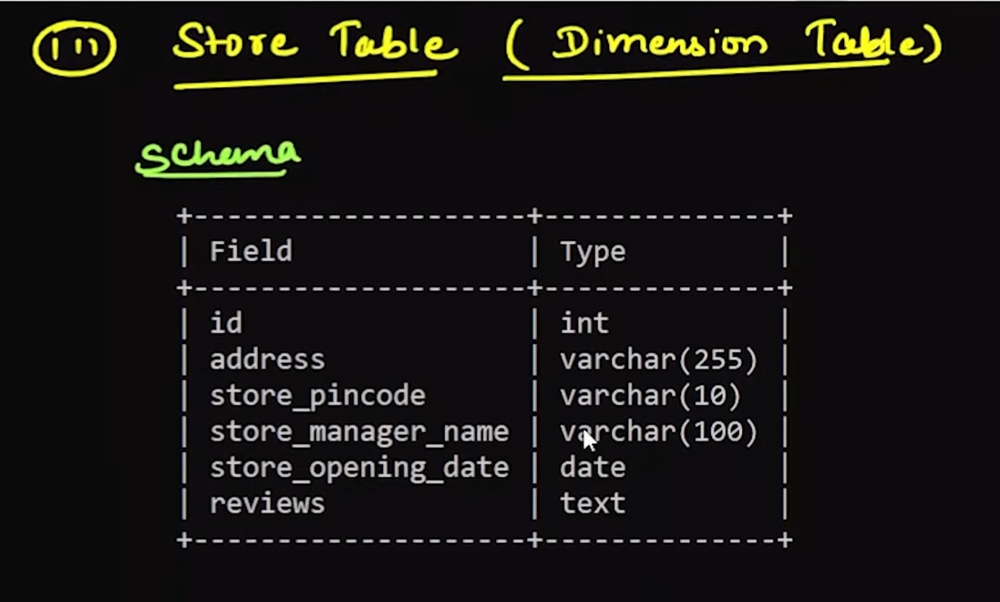

**Store Table (Dimension Table)**

| **Field** | **Type** |
| --- | --- |
| id | int |
| address | varchar(255) |
| store_pincode | varchar(10) |
| store_manager_name | varchar(100) |
| store_opening_date | date |
| reviews | text |

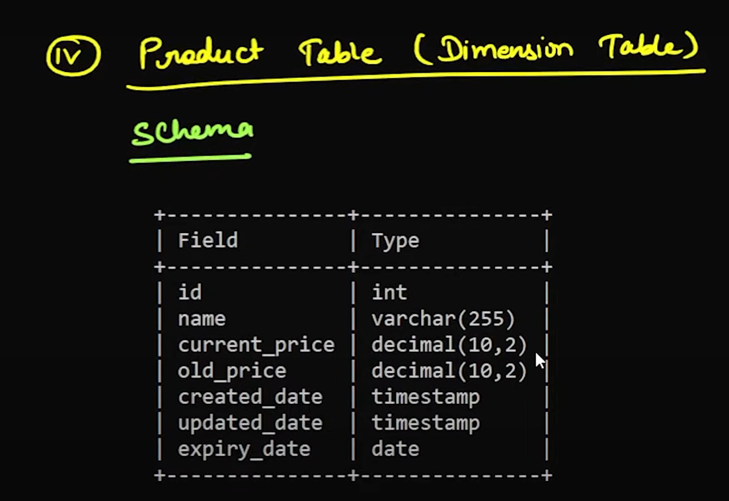

**Product Table (Dimension Table)**

| **Field** | **Type** |
| --- | --- |
| id | int |
| name | varchar(255) |
| current_price | decimal(10,2) |
| old_price | decimal(10,2) |
| created_date | timestamp |
| updated_date | timestamp |
| expiry_date | date |

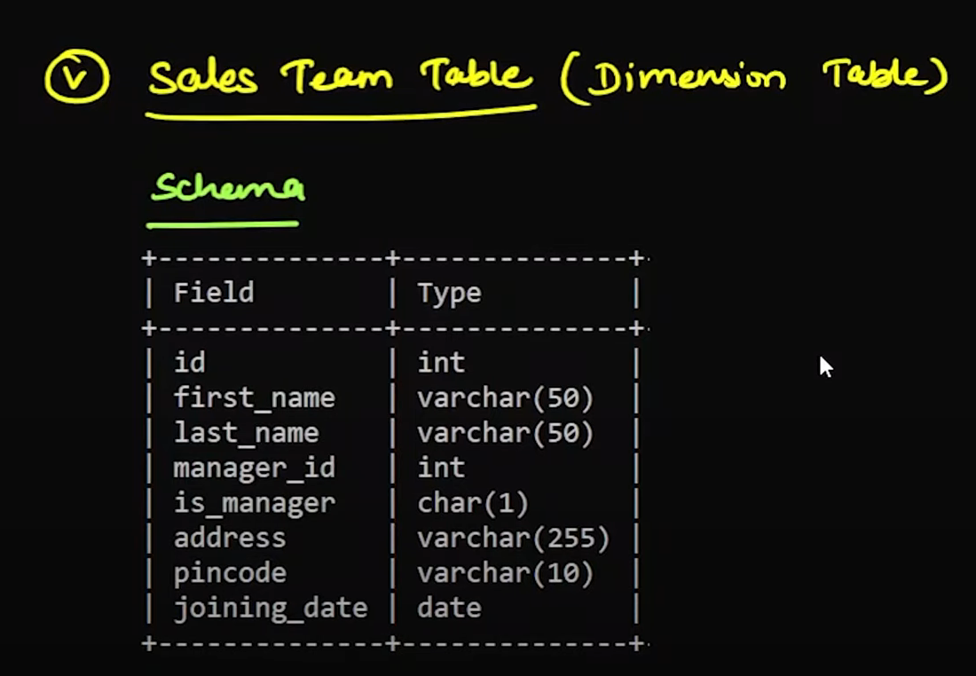

**Sales Team Table (Dimension Table)**

| **Field** | **Type** |
| --- | --- |
| id | int |
| first_name | varchar(50) |
| last_name | varchar(50) |
| manager_id | int |
| is_manager | char(1) |
| address | varchar(255) |
| pincode | varchar(10) |
| joining_date | date |

What will be in the Data Mart

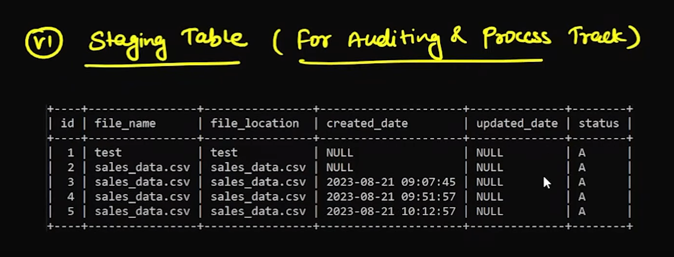

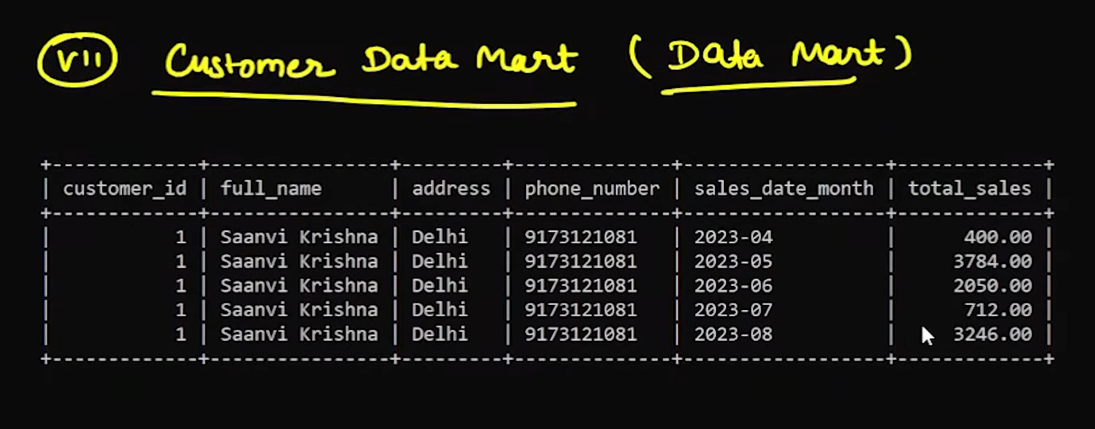

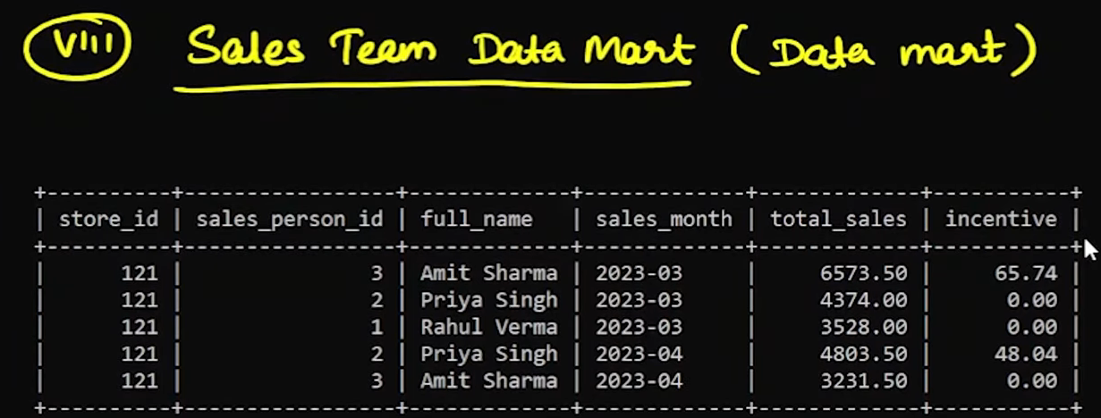

Whatever access keys and passwords that we have we can keep it in the config.py in our project